**County of Henrico**

Department of Public Works

Terrell C. Hughes, P.E., Director

(804) 501-4393

**Public Information Meeting**

**Messer Road Trail Connector**

Tuesday, August 29, 2023

5:00 p.m. – 6:30 p.m.

**Varina Library**

1875 New Market Road, Henrico, VA 23231

**Project Graphic**

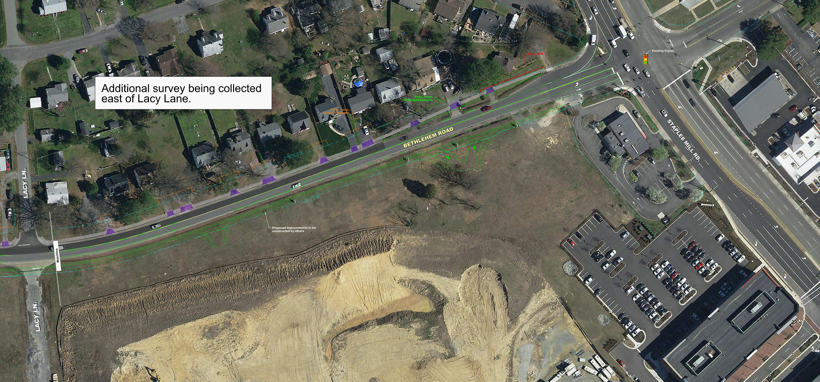

**Environmental Review**

All required environmental clearances and permits will be obtained prior to commencement of construction. Strict compliance with all environmental conditions and commitments resulting from regulatory approvals, and implementation of required specifications and standard best management practices will protect the environment during construction*.*

**Civil Rights**

Representatives from the County are present to discuss the project and answer your questions. It is the responsibility of the County to ensure that all members of the community are afforded the opportunity to provide comments and participate in public decisions on projects affecting them. The County ensures nondiscrimination in all programs and activities in accordance with Title VI of the Civil Rights Act of 1964.

**Right of Way**

Displays at this information meeting show the extent of easements and right of way that may be needed as the project is currently proposed. As the design is further developed, additional easements and right of way may be required beyond what is shown in the current plans. Property owners will be informed of the exact location of the easements during the right of way acquisition process and prior to construction.

**Messer Road Existing Conditions**

Messer Road is an existing two-lane facility that connects New Market Road and Darbytown Road. There are some pedestrian facilities along Messer Road and no existing paved or gravel shoulder. The Virginia Capital Trail follows New Market Road in the vicinity of the project and generally connects Richmond and Williamsburg, Virginia.

**Project Overview: Messer Road Trail Connector**

**Location:** The project is located in eastern Henrico County, approximately seven miles southeast of the City of Richmond, and extends along Messer Road from New Market Road to Varina High School.

**Length:** 0.4 miles

**Purpose:** To connect a 0.4-mile trail from Varina High School along Messer Road to the Virginia Capital Trail at New Market Road.

**Anticipated Cost:** $1.3 Million

**Anticipated Schedule:**

Design: Underway

Right of Way: June 2024

Construction: March 2025

**Project Description: Messer Road Trail Connector**

The Messer Road Trail Connectorwill construct a 12-foot-wide asphalt shared-use path from the intersection of New Market Road (Route 5) and Messer Road to follow along the southeast side of Messer Road, until terminating at the existing sidewalk in front of Varina High School, a distance of approximately 0.4 mile.

The proposed shared-use path would provide improved accommodations for bicycles, pedestrians, and all active transportation users between Varina High School and the existing Virginia Capital Trail. The project is being developed in compliance with the policies contained in Henrico County’s 2026 Comprehensive Plan and *HenricoNext* Comprehensive Plan. Messer Road is also currently identified as an existing minor collector on the Major Thoroughfare Plan included in the 2026 Comprehensive Plan.

The County of Henrico Department of Public Works welcomes you to the Public Information Meeting for the Messer Road Trail Connector project. The purpose of this Public Information Meeting is to provide an opportunity for the public or organizations to provide comments on the proposed project. Henrico County intends on applying for a federal Transportation Alternative grant to fund construction of the trail. The County wants all members of the community to have the opportunity to participate in public involvement on projects affecting them. The County representatives are present to discuss the project and answer your questions. Comments can either be submitted using the comment form provided at tonight’s meeting or via the County’s website at: <https://henrico.us/projects/messer-road-trail-connector/>

County staff will address all questions and concerns raised due to this public information meeting.

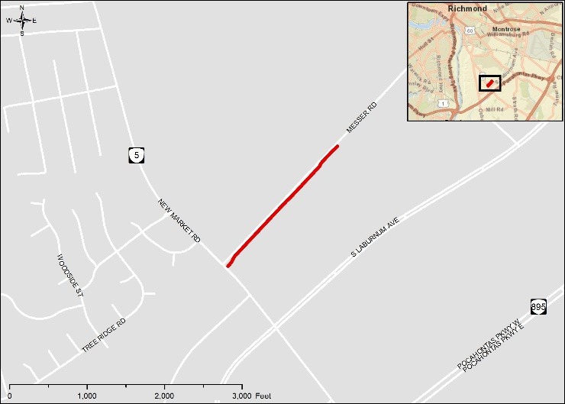

**Get Involved**

Comments on the Messer Road Trail Connector project may be provided at this public information meeting or submitted by mail or email following the public information meeting.

County representatives will review and evaluate any information received. Project information shared here is available on the County website at:

<https://henrico.us/projects/messer-road-trail-connector/>

Comments can also be submitted to Latheasha Hinton ([hin03@henrico.us](mailto:hin03@henrico.us)) or at the contact address below.

**Comments must be postmarked, e-mailed, or delivered to the County by September 15, 2023, to be included in the public information meeting record.**

**Contact Information**

LaTheasha Hinton, Capital Projects Manager

County of Henrico Public Works

Transportation Development Division

P. O. Box 90775

Henrico, VA 23273-0775

(804) 501-5115

[hin03@henrico.us](mailto:hin03@henrico.us)

**Project Location Map**

**Typical Sections**