COMMONWEALTH OF VIRGINIA

COUNTY OF HENRICO

IFB #15-9755-3JC
DEPARTMENT OF FINANCE

CECELIA H. STOWE, CPPO, C.P.M.
PURCHASING DIRECTOR

March 24, 2015

ADDENDUM NO. 1

Invitation for Bid: IFB #15-9755-3JC

Subject: Lawn Maintenance Services

Gentlemen/Ladies:

Please make the following changes, corrections, additions or deletions to the above referenced Invitation for Bid:

This IFB and any addenda are available on the County of Henrico website at:henrico.us/purchasing To download the IFB, click the link and save the document to your hard drive. To receive an email copy of this document please contact com005@henrico.us

Page 2. Section I. Scope of Work/Services: the 2ND paragraph reads:

This service has been provided internally by Recreation and Parks for the past several years. No information is currently available on expenditures for this service. For the fiscal year ending June 30, 201?, the County spent approximately $78,000.00. For the fiscal year ending June 30, 201? the County spent approximately $40,000.00. This data provided is for informational purposes only and does not bind the County to purchase any specified amount.

Shall be changed to read:

This service has been provided internally by Recreation and Parks for the past several years. No information is currently available on expenditures for this service.

Attachment C, Page 25, Insurance Requirements:
Replaced by attached revised Insurance Requirements.

Attachment D, Page 27, Dickendale Property:
The small highlighted triangle to the right of the page shall be excluded from the bid.

Attachment D, Page 28, Twin Hickory Park:
All paved walking trails shall be maintained to a width of (4) four feet on both sides of the trail.

Attachment D, page 29, map of Twin Hickory Recreation Center:
Replaced by attached revised map of Twin Hickory Recreation Center.

1590 E. PARHAM ROAD / PO BOX 90775 /HENRICO VA 23273-0775
(804) 501-5660 FAX (804) 501-5693

Please acknowledge the receipt of Addendum No. 1 dated March 24, 2015 on your Bid Form when returning your Bid package. If your bid has already been mailed, please return this addendum under separate cover referencing the bid due date and time on the outside of the envelope. Failure to acknowledge this addendum may result in your bid being declared non-responsive. All other general terms, conditions and specifications shall remain the same.

Sincerely,

Jacque Comuzzi
Senior Purchasing Officer
804-501-5639
Com005@henrico.us

Signature: ______________________

Print Name: _____________________

Company: ______________________

Date: __________________________

Invitation for Bid: IFB #15-9755-3JC
Questions and Answers
LAWN MAINTENANCE

Q1.Is Workers Compensation insurance required for this bid?
A1. Yes, see attached page 25, Revised Insurance Requirements for this bid.

Q2.Is the insurance coverage required before the bid is turned in?
A2. No, the Certificate of Insurance is not required to be turned in with your bid.

Q3.Attachment C, Page 25, Insurance Specifications, paragraph one, includes Henrico County Public Schools as additional insured, is this necessary?
A3. No, Schools shall not be included, Please see attached page 25, Revised Insurance Requirements Attachment C.

Q4.May I receive a more current map or an approximate measurement of 5007 Twin Hickory Road?
A4. The maps included with the bid are for general purposes, the site visit is intended for measuring purposes. If you were not at the site visit, you are welcomed to visit the sites on your own.

Q5.May I have the zip codes for each property?
A5. Yes, see highlighted areas below.
A5. WEEKLY MAINTENANCE LOCATIONS

- Deep Run Recreation Center – 9910 Ridgefield Parkway Richmond VA 23233-3752
- Spring Park – 2000 Park Street Henrico, VA 23228
- Twin Hickory Recreation Center – 5011 Twin Hickory Road Glen Allen VA 23059
- Twin Hickory Park – 5007 Twin Hickory Road Glen Allen VA 23059

MONTHLY MAINTENANCE LOCATIONS

- Dickendale Property – 2418 Boyle Avenue Richmond, VA 23230

ATTACHMENT C REVISED
Insurance Specifications
County of Henrico

The Successful Bidder shall carry Public Liability Insurance in the amount specified below, including contractual liability assumed by the Successful Bidder, and shall deliver a Certificate of Insurance from carriers licensed to do business in the Commonwealth of Virginia. The Certificate shall show the County of Henrico named as an additional insured for the Commercial General Liability coverage. The coverage shall be provided by a carrier(s) rated not less than “A-“ with a financial rating of at least VII by A.M. Bests or a rating acceptable to the County. In addition, the insurer shall agree to give the County 30 days notice of its decision to cancel coverage.

Workers’ Compensation

Statutory Virginia Limits
Employers’ Liability Insurance - $100,000 for each Accident by employee
$100,000 for each Disease by employee
$500,000 policy limit by Disease

Commercial General Liability - Combined Single Limit

$1,000,000 each occurrence including contractual liability for specified agreement
$2,000,000 General Aggregate (other than Products/Completed Operations)
$2,000,000 General Liability-Products/Completed Operations
$1,000,000 Personal and Advertising injury
$ 100,000 Fire Damage Legal Liability
Coverage must include Broad Form property damage and (XCU) Explosion, Collapse and Underground Coverage

Business Automobile Liability – including owned, non-owned and hired car coverage

Combined Single Limit - $1,000,000 each accident

Excess/Umbrella Liability $1,000,000 per occurrence

NOTE 1: The commercial general liability insurance shall include contractual liability. The contract documents include an indemnification provision(s). The County makes no representation or warranty as to how the Successful Bidder’s insurance coverage responds or does not respond. Insurance coverages that are unresponsive to the indemnification provision(s) do not limit the Successful Bidder’s responsibilities outlined in the contract documents.

NOTE 2: The intent of this insurance specification is to provide the coverage required and the limits expected for each type of coverage. With regard to the Business Automobile Liability and Commercial General Liability, the total amount of coverage can be accomplished through any combination of primary and excess/umbrella insurance. However, the total insurance protection provided for Commercial General Liability or for Business Automobile Liability, either individually or in combination with Excess/Umbrella Liability, must total $3,000,000 per occurrence. This insurance shall apply as primary insurance with respect to any other insurance or self-insurance programs afforded the County of Henrico and Henrico County Public Schools. This policy shall be endorsed to be primary with respect to the additional insured.

NOTE 3: Title 65.2 of the Code of Virginia requires every employer who regularly employs three or more full-time or part-time employees to purchase and maintain workers' compensation insurance. If you do not purchase a workers’ compensation policy, a signed statement is required documenting that you are in compliance with Title 65.2 of the Code of Virginia.
25
Attachment D, REVISED

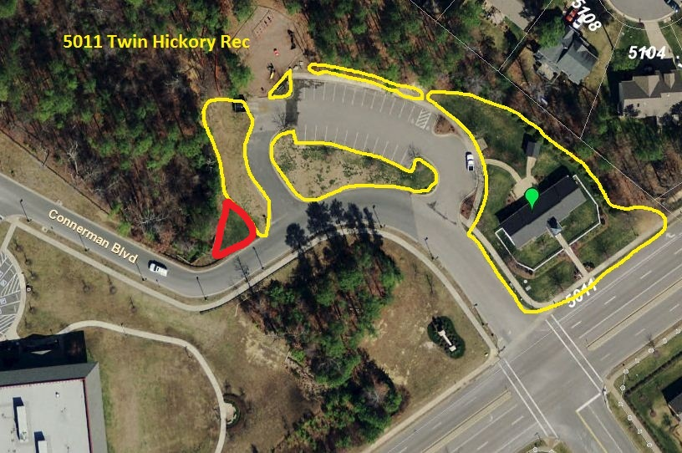

29

