COMMONWEALTH OF VIRGINIA
COUNTY OF HENRICO

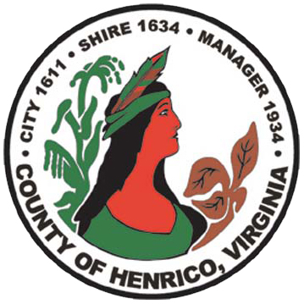

DEPARTMENT OF FINANCE
CECELIA H. STOWE, CPPO, C.P.M.
PURCHASING DIRECTOR

RFP#14-9685-11EF
Analysis of Impediments to Fair Housing Choice
Questions and Answers
December 22, 2014

Q1. The RFP refers to the “Analysis of Impediments to Fair Housing Choice” and the updated Consolidated Plan, so is Henrico planning on releasing a complimentary RFP for assistance to update the Consolidated Plan or is the County staff going to handle the Consolidated Plan update in house using County’s staff?

A1. The Consolidated Plan will be completed in-house using County’s staff.

Q2. AI’s usually require access to HUD’s Integrated Disbursement and Information System (IDIS) system to have the consulting firm place the information it collects and creates directly into IDIS for the locality. Is Henrico going to require the responding firms already have current access to IDIS, are firms required to show they have or can get IDIS access to due the data entry, or will the County be inputting this data into IDIS itself?

A2. Should there be a need to place any information into IDIS, County staff will cover that task.

Q3. The intended start date is February 1st, with the draft report completed by March 15 and the final April 15. Is that correct?

A3. As stated in the RFP document, the scheduled start date is February 1, 2015. Please refer to Sec. III, A.Items 6 and 7 for date for draft and final document to be submitted.

Q4. Are the above dates flexible?

A4. Yes, if mutually agreed upon by the County and the Successful Offeror.

Q5. What is your anticipated budget for this project?

A5. The County has a budget of approximately $30,000.00.

1590 E. PARHAM ROAD / P O BOX 90775 / HENRICO VIRGINIA 23273-0775
(804) 501-5660 FAX (804) 501-5693

