DEPARTMENT OF FINANCE
CECELIA H. STOWE, CPPO, C.P.M.
PURCHASING DIRECTOR

COMMONWEALTH OF VIRGINIA
COUNTY OF HENRICO

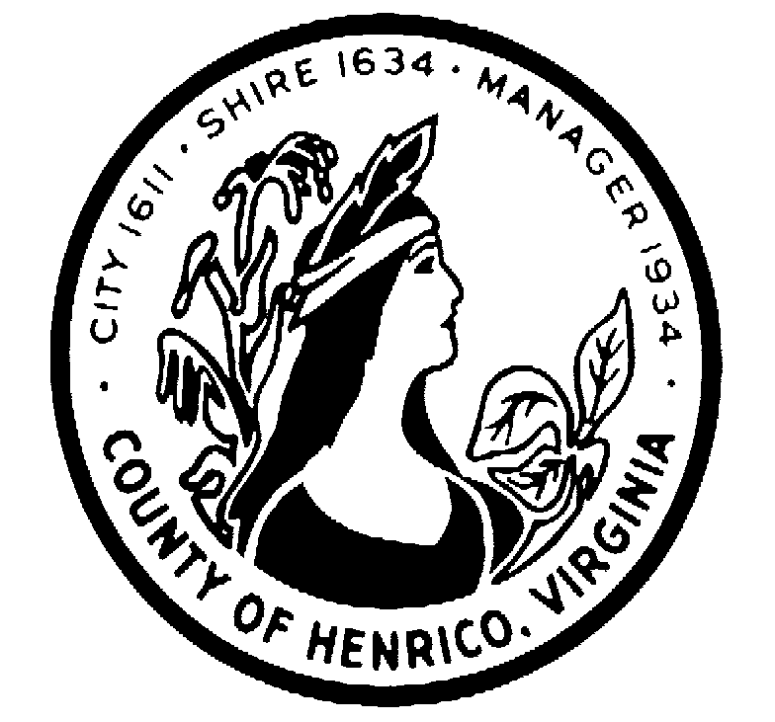
RFP#17-1317-1CS

GROUP MEDICAL PROGRAM
COUNTY OF HENRICO GOVERNMENT AND PUBLIC SCHOOLS

QUESTIONS AND ANSWERS
February 23, 2017

Electronic copies of the full list of Q&A and associated Attachments may be obtained by contacting: Debbie Foster at Wells Fargo Insurance by email at: Deborah.Foster1@wellsfargo.com.

