COMMONWEALTH OF VIRGINIA

COUNTY OF HENRICO
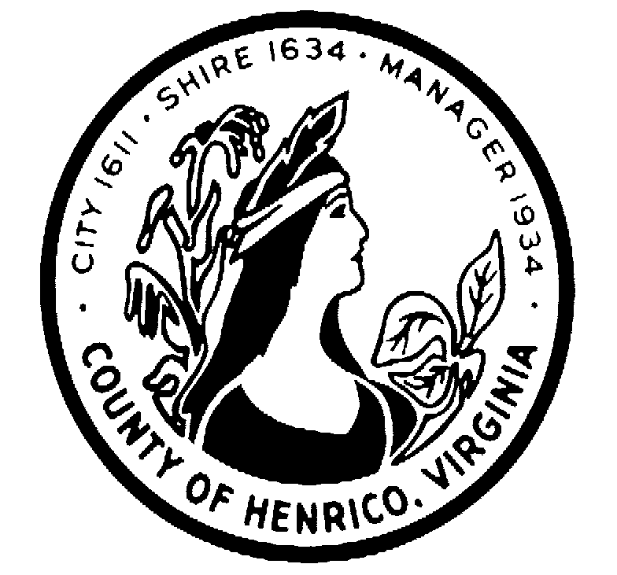

DEPARTMENT OF FINANCE
CECELIA H. STOWE, CPPO, C.P.M.
PURCHASING DIRECTOR

December 22, 2016

ADDENDUM NO. 1

Request for Proposal: #16-1293-11CS

Subject: Alcohol and Drug Testing Services for Community Corrections Program

Gentlemen/Ladies:

Please make the following changes, corrections, additions or deletions to the above referenced Request for Proposal:

This RFP and any addenda are available on the County of Henrico Purchasing website at http://www.henrico.us/purchasing To receive an email copy of this document, please send a request to: bar10@henrico.us

Change due date to read: January 20, 2017, 2:30 p.m.

Unless otherwise changed by an addendum, all other information will remain the same.

Sincerely,

Cecelia H. Stowe, CPPO, C.P.M.
Purchasing Director
Sto05@henrico.us
804-501-5685

8600 Staples Mill Road /PO BOX 90775/HENRICO VIRGINIA 23273-0775
(804) 501-5660 FAX (804) 501-5693

