COMMONWEALTH OF VIRGINIA

COUNTY OF HENRICO
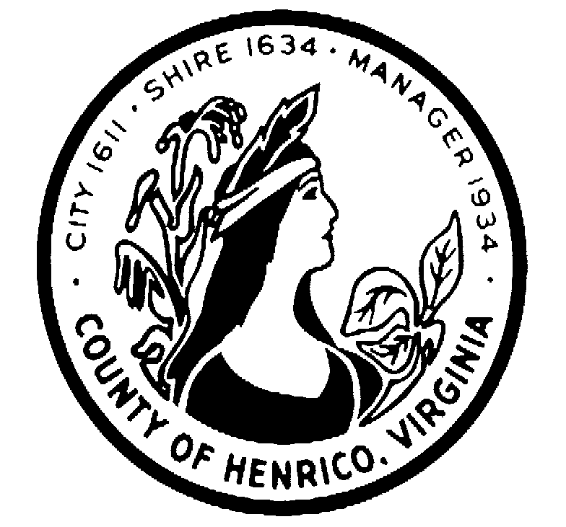

DEPARTMENT OF FINANCE
CECELIA H. STOWE, CPPO, C.P.M.
PURCHASING DIRECTOR

September 15, 2016

ADDENDUM NO. 1

Request for Proposal: #16-1242-8CS

Subject: Engineering Services Water Reclamation Facility Nutrient Removal Upgrades

Gentlemen/Ladies:

Please make the following changes, corrections, additions or deletions to the above referenced Request for Proposal:

This RFP and any addenda are available on the County of Henrico Purchasing website at http://www.henrico.us/purchasing
To receive an email copy of this document, please send a request to: bar10@henrico.us

- Page 19/20 – Attachment B – Proposal Signature Sheet: Replace with the attached Attachment B.

- Questions and answers are attached

Unless otherwise changed by an addendum, all other information will remain the same.

Sincerely,

Cecelia H. Stowe, CPPO, C.P.M.
Purchasing Director
Sto05@henrico.us
804-501-5685

8600 Staples Mill Road /PO BOX 90775/HENRICO VIRGINIA 23273-0775
(804) 501-5660 FAX (804) 501-5693

RFP #16-1242-8CS
ENGINEERING SERVICES
WATER RECLAMATION FACILITY NUTRIENT REMOVAL UPGRADES
COUNTY OF HENRICO, VIRGINIA
Questions & Answers
September 15, 2016

Q1. Whether companies from Outside USA can apply for this? (like, from India or Canada)
All offers submitted will be considered.
Q2. Whether we need to come over there for meetings?
If requested by the County and typically is necessary.
Q3. Can we perform the tasks (related to RFP) outside USA (like, from India or Canada)
Offerors would have to provide detailed information on how they would meet the Scope of Services of the proposal.
Q4. Can we submit the proposals via email?

No.

ATTACHMENT B
PROPOSAL SIGNATURE SHEET
Page 1 of 2

My signature certifies that the proposal as submitted complies with all requirements specified in this Request for Proposal (“RFP”).

My signature also certifies that by submitting a proposal in response to this RFP, the Offeror represents that in the preparation and submission of this proposal, the Offeror did not, either directly or indirectly, enter into any combination or arrangement with any person or business entity, or enter into any agreement, participate in any collusion, or otherwise take any action in the restraining of free, competitive bidding in violation of the Sherman Act (15 U.S.C. Section 1) or Sections 59.1-9.1 through 59.1-9.17 or Sections 59.1-68.6 through 59.1-68.8 of the Code of Virginia.

I hereby certify that I am authorized to sign as a legal representative for the business entity submitting this proposal.

LEGAL NAME OF OFFEROR (DO NOT USE TRADE NAME):
ADDRESS:
SIGNATURE:
NAME OF PERSON SIGNING (print):
TITLE:
TELEPHONE:
FAX:
E-MAIL ADDRESS:
DATE:

Attachment B
Page 2 of 2
Legal Name of Offeror: ____________________________________________________________________
PLEASE SPECIFY YOUR BUSINESS CATEGORY BY CHECKING THE APPROPRIATE BOX(ES) BELOW.

(Check all that apply.)
SUPPLIER REGISTRATION – The County of Henrico encourages all suppliers interested in doing business with the County to register with eVA, the Commonwealth of Virginia’s electronic procurement portal, http://eva.virginia.gov.

eVA Registered? □ Yes □ No

□ SMALL BUSINESS
□ WOMEN-OWNED BUSINESS
□ MINORITY-OWNED BUSINESS
□ SERVICE DISABLED VETERAN
□ EMPLOYMENT SERVICES ORGANIZATION
□ NON-SWAM (Not Small, Women-owned or Minority-owned)
If certified by the Virginia Minority Business Enterprises (DMBE), provide DMBE certification number and expiration date. ___________________NUMBER ______________________DATE
definitions
For the purpose of determining the appropriate business category, the following definitions apply:
"Small business" means a business, independently owned and controlled by one or more individuals who are U.S. citizens or legal resident aliens, and together with affiliates, has 250 or fewer employees, or annual gross receipts of $10 million or less averaged over the previous three years. One or more of the individual owners shall control both the management and daily business operations of the small business.
"Women-owned business" means a business that is at least 51 percent owned by one or more women who are U.S. citizens or legal resident aliens, or in the case of a corporation, partnership, or limited liability company or other entity, at least 51 percent of the equity ownership interest is owned by one or more women who are U.S. citizens or legal resident aliens, and both the management and daily business operations are controlled by one or more women.
"Minority-owned business" means a business that is at least 51 percent owned by one or more minority individuals who are U.S. citizens or legal resident aliens, or in the case of a corporation, partnership, or limited liability company or other entity, at least 51 percent of the equity ownership interest in the corporation, partnership, or limited liability company or other entity is owned by one or more minority individuals who are U.S. citizens or legal resident aliens, and both the management and daily business operations are controlled by one or more minority individuals.
"Minority individual" means an individual who is a citizen of the United States or a legal resident alien and who satisfies one or more of the following definitions:
1. "African American" means a person having origins in any of the original peoples of Africa and who is regarded as such by the community of which this person claims to be a part.
2. "Asian American" means a person having origins in any of the original peoples of the Far East, Southeast Asia, the Indian subcontinent, or the Pacific Islands, including but not limited to Japan, China, Vietnam, Samoa, Laos, Cambodia, Taiwan, Northern Mariana Islands, the Philippines, a U.S. territory of the Pacific, India, Pakistan, Bangladesh, or Sri Lanka and who is regarded as such by the community of which this person claims to be a part.
3. "Hispanic American" means a person having origins in any of the Spanish-speaking peoples of Mexico, South or Central America, or the Caribbean Islands or other Spanish or Portuguese cultures and who is regarded as such by the community of which this person claims to be a part.
4. "Native American" means a person having origins in any of the original peoples of North America and who is regarded as such by the community of which this person claims to be a part or who is recognized by a tribal organization.
"Service disabled veteran business" means a business that is at least 51 percent owned by one or more service disabled veterans or, in the case of a corporation, partnership, or limited liability company or other entity, at least 51 percent of the equity ownership interest in the corporation, partnership, or limited liability company or other entity is owned by one or more individuals who are service disabled veterans and both the management and daily business operations are controlled by one or more individuals who are service disabled veterans.
"Service disabled veteran" means a veteran who (i) served on active duty in the United States military ground, naval, or air service, (ii) was discharged or released under conditions other than dishonorable, and (iii) has a service-connected disability rating fixed by the United States Department of Veterans Affairs.

“Employment services organization” means an organization that provides community-based employment services to individuals with disabilities that is an approved Commission on Accreditation of Rehabilitation Facilities (CARF) accredited vendor of the Department of Aging and Rehabilitative Services.

