COMMONWEALTH OF VIRGINIA
COUNTY OF HENRICO

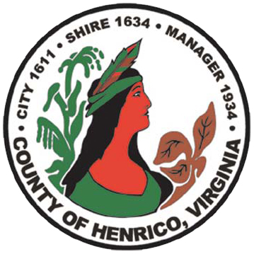

DEPARTMENT OF FINANCE
CECELIA H. STOWE, CPPO, C.P.M.
PURCHASING DIRECTOR

RFP# 16-1117-1EF
ANNUAL CONTRACT FOR PREVENTIVE MAINTENANCE AND REPAIRS
FOR THE ELECTRICAL DISTRIBUTION SYSTEM – PUBLIC UTILITIES
QUESTIONS AND ANSWERS
February 2, 2016

Q1. Please clarify if manufacturers are invited to participate in bidding on this RFP.

A1. Per Sec.III.O. of the RFP manufacturers are not able to bid on this RFP.

8600 Staples Mill Road / PO BOX 90775 / HENRICO VIRGINIA 23273-0775
(804) 501-5660 FAX (804) 501-5693

