DPW Construction Division – Policy Memorandum
Curb ramp requirements and standards overview

Background:
The information below is intended to address commonly asked questioned and more clearly define the Department of Public Work’s expectations regarding the standards for design and construction of curb ramps.
The majority of information within this document has been in effect within various VDOT standards as referenced below. The requirements within this policy are effective for all County roadway projects in Henrico County as of April 7, 2017.

Reference info:
- VDOT IIM-LD-55.16 - Rev. July 15, 2014 (latest version as of 2/13/17)

- VDOT Road and Bridge Standards – “CG-12 detectable warning surface”, Rev. July, 2015

- Proposed Accessibility Guidelines for Pedestrian Facilities in the Public Right-of-Way (PROWAG) – Rev. July 26, 2011

- 2010 ADA Standard for Accessible Design - Rev. September 15, 2010

- Sect. 15.2-2021, Code of Virginia ;
Excerpt:
Notwithstanding the provisions of subsection A of § 15.2-2000, every locality requiring curbs along its streets that incorporate accessible routes for pedestrian use, such as existing or proposed sidewalks, shall require that curb ramps be constructed at intersections for use by persons with mobility impairments. The ramps shall comply with the Virginia Department of Transportation's Road and Bridge Standards. Local option, variance, or waiver of these standards is prohibited.

Overview of ramp characteristics:
CURB RAMP ELEMENTS AND TYPES
- RAMP
A curb ramp consists of a ramp, with a maximum running slope of 12:1 (8%) and its accompanying landing(s), with flares on each side where appropriate. A ramp can cut through a median curb or rise up to the landing or Pedestrian Access Route.

- LANDING
A level area of a curb ramp with a cross slope of less than 48:1 (2%). For perpendicular curb ramps, the landing allows pedestrians to bypass the flares and ramp and provides a level maneuvering space for persons using wheelchairs entering or exiting the ramp. For parallel curb ramps, the landing is between the ramps. The landing clear width shall be a least as wide as the curb ramp, excluding flared sides, leading to the landing. In alterations, where there is no landing at the top of the curb ramp, the curb ramp flares shall be provided and shall not be steeper than 12:1 (8%). See drawing below as well as the Road and Bridge Standards.
The type of curb ramp is determined by the direction the user is traversing the ramp in relation to the vehicular path of travel. The three (3) types of curb ramps are: Perpendicular Design (CG-12, Type A), Parallel Design (CG-12, Type B) and Combined (Parallel and Perpendicular) Design (CG-12, Type C).
- FLARE*
Flared Sides Where a pedestrian circulation path crosses the curb ramp, flared sides shall be sloped 10 percent maximum, measured parallel to the curb line.
Flared Sides The flared sides are part of the pedestrian circulation path, but are not part of the pedestrian access route. Curb ramps whose sides have returned curbs provide useful directional cues where they are aligned with the pedestrian street crossing and are protected from cross travel by landscaping, street furniture, chains, fencing, or railings.
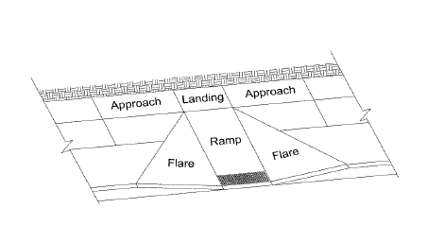
Curb ramp element detail view

General sidewalk and accessible route constraints:

- New Pedestrian Access Routes (Sidewalk or Sidewalk Space) less than 5 feet in continuous width excluding the width of curb shall provide a pedestrian passing area a minimum of 5 feet x 5 feet at reasonable intervals not to exceed 200 feet. These passing areas can be provided at street intersections with cross slopes no greater than 48:1 (2%).

- Where pedestrian access routes are contained within a street or highway right-of-way, the grade of pedestrian access routes shall not exceed the general grade established for the adjacent street or highway. Where pedestrian access routes are not contained within a street or highway right-of-way, the grade of pedestrian access routes shall be 5% maximum.

- The Pedestrian Access Route surfaces shall be firm, stable, and slip resistant and openings that are more than 1/2" in one dimension are prohibited. The pedestrian access route is permitted level changes up to 1/4" without treatment and level changes between 1/4" and 1/2" that are beveled with a slope no greater than 2:1.

- Curb ramps shall conform to the Road and Bridge Standard CG-12, Type A, B or C and Sections 502 and 504 of the Road and Bridge Specifications. The designer shall ensure curb ramps are graphically depicted accurately on plans, drawn to scale, and annotated to denote the Type of Curb Ramp (CG-12, Type A, B or C). Curb ramps shall be constructed of hydraulic cement concrete with a detectable warning surface in accordance with the Special Provision “CG-12 Detectable Warning Surface.”

- Where pedestrian access routes cross entrances (whether private or public/ commercial), the grade and width of the pedestrian route shall be maintained through the entrance. This means the running slope of the entrance must transition to meet the cross slope of pedestrian route where the two intersect. In the cases of CG-9D entrances, the pedestrian access route may be located beyond the entrance provided additional Right of Way or permanent easement is recorded.

Constraints of each ramp feature:
There are five main features of concern with curb ramps and each section is listed below:
- Trigger for installation
- Ramp type and orientation
- Ramp and landing width
- Running slope and cross slope
- Detectable warnings, type and alignment

Section 1: Trigger for installation

- Curb ramps shall be provided wherever a pedestrian access route (sidewalk or sidewalk space) crosses a curb regardless of whether sidewalk is existing, proposed, or non-existent. For example, if the current typical section or the proposed typical section includes a pedestrian access route (sidewalk or sidewalk space), curb ramps shall be installed. However, if a pedestrian access route (sidewalk or sidewalk space) does not exist and is not being proposed, do not install a curb ramp.

Public Works has interpreted the above line to mean that curb ramps will be required any time the roadway typical section calls for an area beyond the curb which is of equivalent geometry to a sidewalk. Since Henrico County typical sections call for a pedestrian shelf at ¼ in. per 1 ft. and a width exceeding the min. sidewalk width, curb ramps are required even when sidewalk is not proposed as part of the project.

- Construction of the entire Standard CG-12, Type A, B or C is required. Construction of the wiped down section of curb only, with intentions of installing the curb ramp when/if a sidewalk is installed along the pedestrian access route, is not acceptable.

Section 2: Ramp type and orientation

- One curb ramp shall be provided for each direction of an intersection crossing, where feasible. Curb ramps shall be in-line with the direction of pedestrian travel to improve wayfinding for visually impaired pedestrians.

- Diagonal Curb Ramps for all three Types (A, B and C) can only be used when certain conditions apply and a 4 feet by 4 feet square landing area at the bottom of the ramp and outside of the travelway shall be provided within the marked crosswalk. See VDOT Road Design Manual, Appendix A, Section A-5, Figure A-5-17 and Figure A-5-18.

- Henrico County will not allow the landing area to be placed beyond the edge of pavement. The entire 4 ft. by 4 ft. landing area must be provided beyond the edge of pavement, outside of the roadway. The landing area may include the gutter pan.

- See grade information below for situations where diagonal (corner) curb ramps are allowed and have been proposed in plans.

Section 3: Ramp and Landing width
- When curb ramps are used in conjunction with a shared use path, the minimum width shall be the width of the shared use path.

- The width of curb ramps (excluding the flares) for shared use paths shall be the same width as the width of the shared use path and include detectable warning surfaces on the entire width of the path.

- The width of the ramp for sidewalk must be no less than the sidewalk approaching the ramp.

- In cases where the sidewalk grade transitions to provide a ramp, (see CG-12, type C) any curb constructed to hold earthen material behind the edge of the sidewalk must be placed outside of the edge of the sidewalk in order to provide a consistent width of the accessible path.

Section 4: Running slope and cross slope

- Maximum cross slope for sidewalk is 2%.
- Maximum running slope for ramp (grade transition) is 8%.
- When diagonal ramps are allowed, a landing area of a minimum 4 ft. by 4ft. dimension must be provided. The maximum slope of the landing area is 2% in each direction.
- VDOT Road and Bridge standards detail, CG-12 gives examples of typical ramp layouts and geometric constraints.
- Each CG-12 shall be designed to ensure proposed CG-12 geometrics will work with adjacent roadway design elements to meet current ADA requirements as published by VDOT. See example detail below:
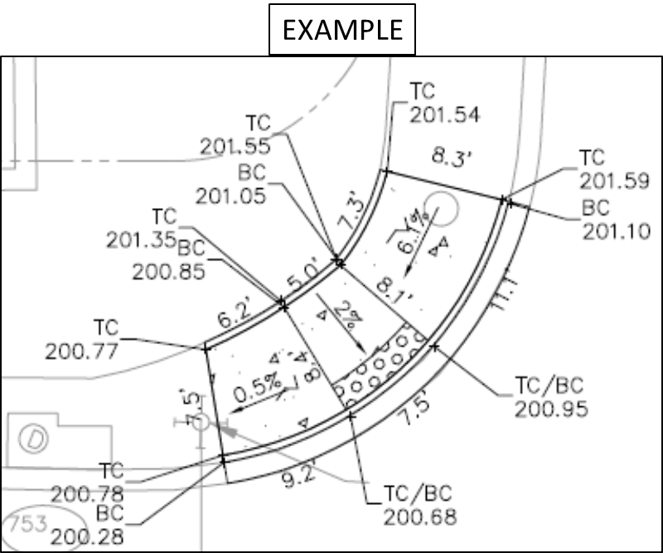

Section 5: Detectable Warnings, type and alignment
- The detectable warning shall be provided by truncated domes.

- Detectable warning shall be from the materials approved list for detectable warning surfaces.

- Detectable warning surfaces are required:
  - Where a sidewalk or shared use path crosses a vehicular way, excluding un-signalized driveway crossings (private entrances)
  - When pedestrian access routes cross medians and refuge islands, a cut through less than 6 ft. in length (median width) shall not have detectable warning surfaces installed. See Road and Bridge Standard CG-12 and Median (Type M1 or M2) or Refuge Island (Type RI1 or RI2)

- All cases where curb ramps intersect a radial section of curb at entrances or street connections the detectable warning surface shall have a factory radius of be field modified as recommended by the manufacture to match the back of curb

- We have not yet identified any manufacturers that offer detectable warnings with a radius that meets all County entrance and intersection radii. When diagonal curb ramps are allowed (see section 2) detectable warning placement will be determined on a case by case basis and should be placed as close to the back of curb as possible.

Questions?
Please contact either the Construction Division or Environmental and Engineering Services Division of the Department of Public Works at (804) 501-4393

